**Addendum - Beta feature: Protocol A-AV – PPG**

Addendum – OneStim UIM V0.2.docx

To be used only for Clinical Investigations

approved by Ethics Committee

Amendment Control

|  |  |  |  |
| --- | --- | --- | --- |
| Version | Date | Pages/ Sections Changed | Who |
| 0.1 | 5.2.22 | Initial | MC |
| 0.2 | 8.4.24 | Added PPG & Data saving | MC |

Contents

1. Product Contents 1

2. Protocol Description 1

3. Procedure 2

4. Limitations 3

5. Data storage format 3

6. Digital Signal outputs - Obsolete 5

# Product Contents

1. OneStim Console MP4011-4BM, SN00103
2. Patient Connection Box MP4075-4B, M00000039
3. PPG Sensor Assembly MP4147, v1.0, SNs 01 & 02
4. Hope-PPG Software V1.28.18.1

# Risk Analysis

| Risk | Criticality | Mitigation | Accepted |
| --- | --- | --- | --- |
| PPG sensor LED too hot and burns finger | Low | Integrated Sensor MAX30102, LED power 9.8mW – cannot burn | Accept |
| Incorrect Data - wrong heart rate | Low | HR calculated from ECG signal, not from PPG | Accept |
| Incorrect data – PPG amplitude measurement errors – corrupts clinical trial | Medium | PPG signal used only for second-to-second relative change in amplitude, which is unlikely to vary incorrectly | Accept |
| Data Interference – finger movement or change in pressure | Medium | Subject is instructed and supervised during study for movement artefacts | Accept |
| Data Interference – respiratory variation in PPG amplitude | Medium | Mitigated by study protocol averaging across multiple respiratory cycles | Accept |

# Cautions and Precautions

1. Device is to be used only for Clinical Investigations approved by Ethics Committee.
2. Device data is not validated for any clinical indication or meaning – user must interpret based on their own clinical investigations.
3. No patient treatment should be based on the results of use of this device, except as a part of a clinical trial.
4. Use of device on subjects must be supervised at all times to ensure quality of data collected.
5. Finger PPG from supplied PPG sensor depends greatly on the size of the finger – choose a finger with best PPG signal (a better sensor is in development)

# Protocol Description

1. This protocol is released for use in clinical studies only.
2. The protocol provides basic Atrial pacing alternating with A-V pacing every set number of Atrial stimuli, for a total number of atrial stimuli, after which A-V interval is decremented.
3. It also provides photoplethysmography (PPG) signal trace.
4. Pacing data, EGM / ECG and PPG signals are recorded to CSV file

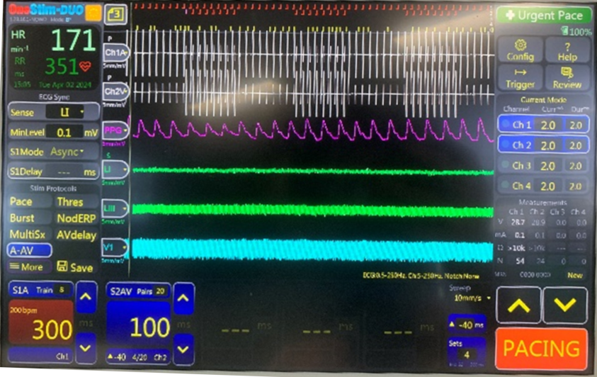

S2 Auto-Decrement

S2 Interval

S2 Train

S1 Train

Alternating A and AV pacing sequences: 8 each

Figure 1: Hope Protocol OneStim Display

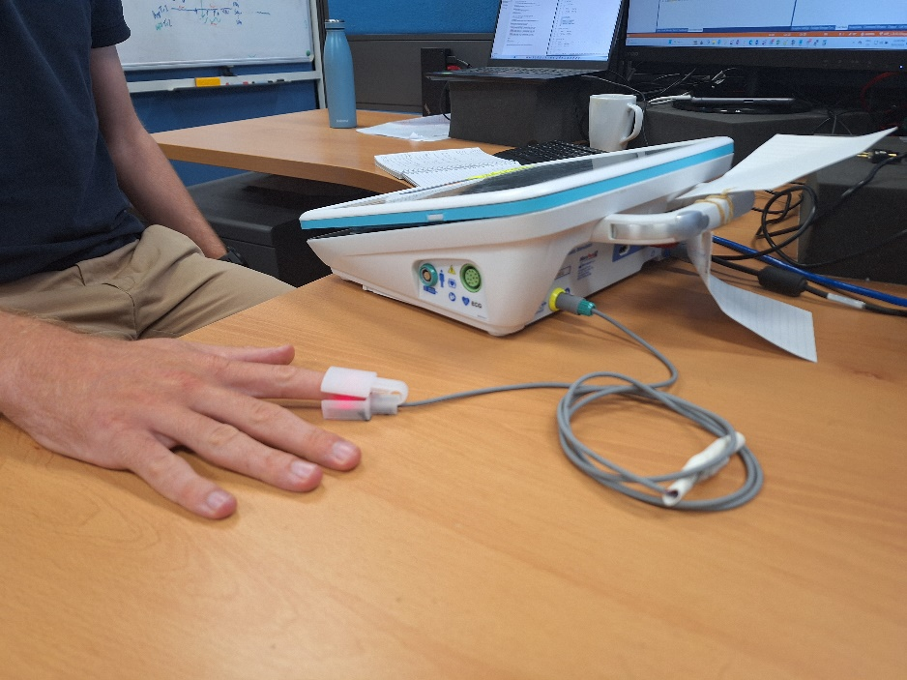

Figure 1: Hope Protocol PPG connection (incorrect position wih finger / PPG on table – hand should be elevated above table so finger is in mid air.

# Procedure

**Setup**

1. Insert USB to save Data
2. Connect Chan 1 into Atrium and Chan2 into Ventricle EGM
3. Set S1 to basic atrial cycle length, e.g. 800ms
4. Set S2 to starting A-V Delay
5. Set Config / C.Stim Settings #35 Min Sx (S2-S5) AutoDecr to the lowest AV delay value to which you want t auto-decrement
6. Set S2 Train to number of stimuli on which to alternate A pacing with AV Pacing, e.g. 8
7. Set S1 Train to total number of Atrial stimuli (A-AV pairs) before auto-decrementing AV, e,g, if S2 Train is 8, then to obtain 4 repetitions of A-AV pairs, set S1 Train to 8 x 2 x 4 = 64.

**Attach PPG**

1. Connect PPG device to OneStim Rear Auxiliary SIP/SOP socket
2. Place PPG on finger, adjust until obtain stable PPG signal
3. Support hand off the table so PPG device in suspended in mid-air, so that subject cannot vary pressure on the sensor as could be done if PPG were resting on the table.
4. Try using different fingers to obtain PPG signal with good diacrotic notch

**Pacing**

1. Start Pacing
2. You can leave to repeat A – AV pairs for a total S1 Train pulses before it auto-decrements every S1 Train A paces.
3. If you stop pacing – Train Counters reset to 0.

| **Pacing Parameter** | **Value** |
| --- | --- |
| S1 | Basic Atrial pacing cycle length, e.g.800ms |
| S2 | A-V Delay ms |
| S1 Train | Total number of Atrial stimuli before auto-decrementing AV Interval, nominally 64 |
| S2 Train | Number of stimuli in each alternating A and A-V sequences, nominally 8 |
| Decrement | S2 Auto-decrement, after each S1 stimuli. Set to 0 to disable |

# Limitations

Please note the following limitations for the HOPE PPG Protocol:

1. **No changes while pacing -** Do not change trace display speed or pacing protocol parameters while pacing – otherwise pacing sequence will be incorrect, PPG amplitudes will display incorrectly and protocol change will not be recorded in csv file.
2. **In QRS Detection Menu**, detection works only for the default +ve threshold – do not select -ve threshold to avoid failure to detect QRS.
3. **Trace Display -** Do not change the order of Ch1, Ch2 and PPG traces – changing order may not display traces correctly.

Please note that the 3D printed PPG

# Data storage format

**Data file format (ECG recording)**

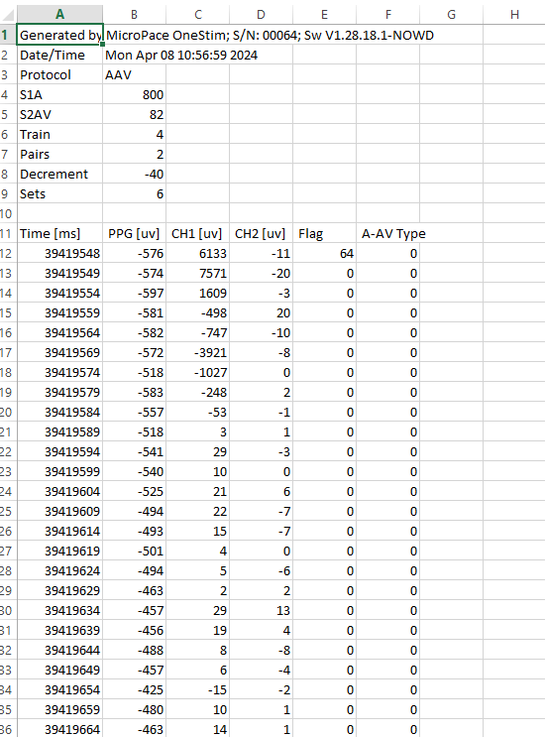

**Data file format (PPG analysis)**

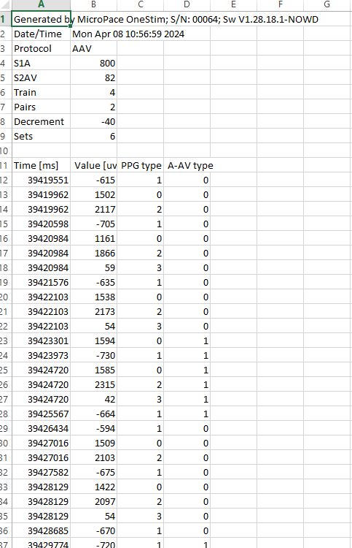

**File format Description**:

[[ONESTIM-2597] Hope-AF: Log data from AAV protocol - MICROPACE JIRA](http://jira.mplan:8085/browse/ONESTIM-2597)

The data are saved in two different kinds of file:

* ECG recording file, name AAV_DATA_*Date_MRN_increment*.CSV
  + e.g. for a file from 27th March 2024 with MRN of 12341234 and the 6th file of the day -> AAV_DATA_20240327_12341234_0005.CSV
  + This file will contain the ECG data for PPG, Ch1, Ch2, Flag and Type with a resolution of 5ms (200 sps) and the date and setting of the Set. A new file is created for each new Set.
    - PPG, Ch1, Ch2: Data in uV
    - Flag: ECG_CHANNEL_FLAGS, to be interpreted has individual bit (See Flag definition in annexe)
      * If there is a flag but not align with the resolution of 5ms, the data are save anyway.
    - A-AV Type: The data is during A or AV (0 = A, 1 = AV)
    - Time: time in ms: hours(in ms) + minutes(in ms) + seconds (in ms) + milliseconds
      * e.g. data append at 15:47:12 and 45 ms (56832045)
* PPG analyze file, name PPG_DATA_*Date_MRN_increment*.CSV
  + e.g. for a file from 27th March 2024 with MRN of 12341234 and the 6th file of the day -> PPG_DATA_20240327_12341234_0005.CSV
  + This file will contain the PPG analysis data from a Set (Peak, Trough, amplitude, HR). A new file is created for each new Set.
  + PPG Type: The type of the data
    - Peak: 0
    - Trough: 1
    - Amplitude: 2 (Time when the amplitude has been detected (Trough-peak amplitude - time at the peak))
    - Heart Rate: 3 (in [pbm]) (Time when the HR has been detected (Peak-Peak - time at the second peak))
  + A-AV Type: The data is during A or AV (0 = A, 1 = AV)
  + HR: heart rate in bpm (calculated with the time between two peak) (min and max HR to be considerate and save 12 < HR < 214)
  + Time: time in ms: hours(in ms) + minutes(in ms) + seconds (in ms) + milliseconds
    - e.g. data append at 15:47:12 and 45 ms (56832045)

# Digital Signal outputs - Obsolete

This cable no longer applicable because data is saved into USB file.

~~OneStim A-AV protocol outputs digital 3.3V x 10ms pulses from two AUX Digital outputs (DOUT1 and DOUT2) for A and V stimuli respectively. Use MP4003A cable to interface.~~

~~You may input these to your EP Recorder Stim channel to indicate pacing states for analysis.~~

Plug into OneStim rear

“AUX MP4003” socket

Ext High Level ECG Input marker

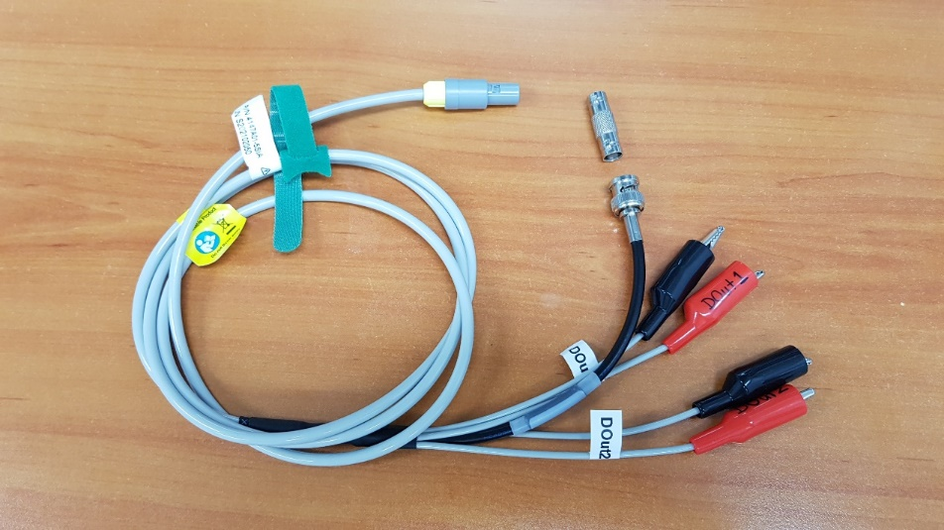

DOUT2-Chan 2 (V) Stim marker

DOUT1-Chan 1 Stim (A) Stim marker

Figure 2: Aux MP4003A Cable